**Guidelines and recommendations for the allocation of CATZOC/QoBD values from survey data.**

**Data Quality Working Group**

**Document Control**

|  |  |  |  |
| --- | --- | --- | --- |
| **Edition Number** | **Date** | **Author** | **Notes** |
| **0.1** | **October 2021** | **DQWG CATZOC SubWG** | **Initial draft for further discussion and amendments** |
|  |  |  |  |
|  |  |  |  |
|  |  |  |  |
|  |  |  |  |
|  |  |  |  |

1. **Preface**

The Data Quality Working Group (DQWG) should provide guidance on data quality aspects to hydrographic offices, in particular to ensure harmonized implementation (Terms of Reference art.3.b.iv). At DQWG16 (Feb2021, VTC) a dedicated subWG was created with the task of drafting guidelines and recommendations for Hydrographic Offices (HO’s) based on best practice to help inform the allocation of CATZOC values (or S-101 Quality of Bathymetric Data values) from survey data qualified in application of the new Ed. 6.0 of S-44 – IHO Standards for Hydrographic Surveying.

This document aims to provide standardised guidance and recommendations for allocating CATZOC/QoBD values from survey data. It describes the process from the first ping (data capture) to data storage (S-57, S-101, S-102), validation and finally descriptive quality indicator (CATZOC, QoBD) to provide the end user with meta-information to assess if a dataset will fulfil his/her requirements (fit for purpose / fitness for use).

1. **Introduction**

S-101 and S-102 are under development. Combining datasets of these types requires dissemination of appropriate data quality elements and appropriate meta-quality information (CATZOC) to the mariners in order to facilitate safe route planning and voyage execution.

Datasets provided by adjacent HO’s may provide different depictions of the shape of the seabed and associated quality indicators. This work aims to provide tools to make an assessment of the self-consistency of datasets produced by one HO and may explain the differences to datasets produced by the adjacent HO

Additionally, it is hoped that this work may help HO’s to have more confidence in including crowd sourced bathymetric (CSB) data into their nautical charts where it is considered appropriate to do so.

From Survey to CATZOC, describes the process from the first ping (data capture) to data storage (S-57, S-101, S-102), validation and finally descriptive quality indicator (CATZOC, QoBD) to provide the end user with meta-information to make an assessment of whether the dataset is fit-for-purpose. Consideration is given to each of the following items within this document:

* *Hydrographic Surveys and Data capture*, and more specifically the associated accuracy and evaluation according to S-44 Ed 6.0.0.
* *Vector Data Storage* in S-57 format and S-101 format, with a focus on soundings, depth contours, and depth areas.
* *Gridded Data Storage* in S-102 format and associated uncertainty values.
* *Data generalization.*
* *Data quality* measures and recommended target results (validation).
* Assigning appropriate CATZOC (S-57) and Quality of Bathymetric data (S-101) values.
* Added value of CSB data.

This document aims to set out the principles for describing the quality for geographic data and concepts for handling quality information for geographic data, and a consistent and standard manner to determine and report a dataset’s quality information. It aims also to provide guidelines for evaluation procedures of quantitative quality information for geographic data.

Working with data quality includes a consideration of the following::

* Understanding of the concepts of data quality related to geographic data.
* Defining data quality conformance levels in data product specifications or based on user requirements (establishment of data product specifications is described in ISO 19131:2007);
* Specifying quality aspects in application schemas;
* Evaluating data quality;
* Reporting data quality.

1. **Hydrographic Surveys and Data Capture**

The elevation of a terrain surface, is one of the most important descriptors of the Earth‘s morphology. A Digital Elevation Model (DSM) is a three dimensional representation of the earth’s surface providing an elevation property with reference to a specified origin (vertical reference or datum). When an elevation property describes the bare surface of the land or sea floor, the related model is called Digital Terrain Model (DTM). When an elevation property includes the heights of the objects present on the surface it is referred to as a Digital Surface Model (DSM).[1]

Nowadays capturing the elevation of a terrain surface on land is mostly done from an airplane using a LIDAR sensor. For capturing bathymetric data information is collected about the depths and shapes of the seabed and underwater terrain primarily using a combination of ship mounted echo sounders (multibeam, single beam), airplanes (LIDAR) or satellite (SDB)[2]. When measuring from ship, a distinction can be made between 1) official and officially sponsored surveys, 2) unofficial surveys, 3) passage surveys; see also IHO publication S-4, B-611 Credibility of sources. IHO Publication S-44 defines the standards applicable to hydrographic surveys and sets minimum standards to be achieved based on the intended use of the data.

Official (and officially sponsored) surveys prepared specifically for nautical charting should be validated by competent surveyors. It must be ensured, as far as possible, that any errors and uncertainties arising from the method of surveying are understood and that the survey remains acceptable for use; see IHO publication S-4.[3] IHO publication S-44 describes the orders of safety of navigation surveys which are considered acceptable for the production of navigational products and services to enable surface vessels to navigate safely. As requirements may vary five different order s of survey are defines each designed to cater for a different range of needs and these are set out in Table 1:

Table 1: S-44 Classifications of safety of navigation surveys.

|  |  |  |
| --- | --- | --- |
| **Order** | **Characteristics** | **Intended usage** |
| **2** | General depiction of the bottom is considered adequate. Evenly distributed bathymetric coverage of 5% | Areas deeper than 200m. Existence of features that are large enough to impact on surface navigation and yet still remain undetected is considered to be unlikely. |
| **1b** | General depiction of the bottom is considered adequate. Evenly distributed bathymetric coverage of 5% | Only recommended where underkeel clearance is considered not to be an issue. An example would be an area where the bottom characteristics are such that the likelihood of there being a feature on the bottom that will endanger the type of surface vessel expected to navigate the area is low. |
| **1a** | 100% feature search, bathymetric coverage less than or equal to 100% is appropriate as long as the least depths over all significant features are obtained and the bathymetry provides an adequate depiction of the nature of the bottom topography. | Coastal waters, harbours, berthing areas, fairways and channels.  Underkeel clearance becomes less critical as depth increases, so the size of the feature to be detected increases with depth in areas where the water depth is greater than 40 meters. |
| **Special** | 100% feature search and 100% bathymetric coverage. Size of the features to be detected is more demanding than order 1a. | Areas where underkeel clearance is critical. Examples are: berthing areas, harbours and critical areas of fairways and shipping channels. |
| **Exclusive** | 200% feature search and 200% bathymetric coverage. Size of the features to be detected is more demanding than special order. | Shallow water areas (harbours, berthing areas and critical areas of fairways and channels) where there is an exceptional and optimal use of the water column and where specific critical areas with minimum underkeel clearance and bottom characteristics are potentially hazardous to vessels. |

Table 2:

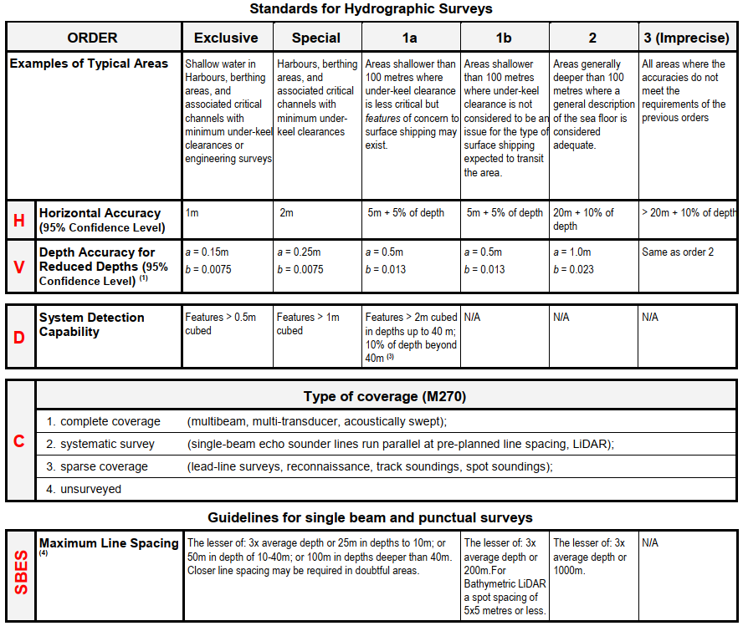

## 3.1 Horizontal and vertical positioning and its associated uncertainty

Positioning is a fundamental part for every survey operation. The hydrographer must consider the geodetic reference frame, horizontal and vertical reference systems, their connections to other systems in use (e.g., land survey datum’s), as well as the uncertainty inherent within associated measurements. In IHO Publication S-44 Ed.6.0.0 position and its uncertainty refer to the horizontal component of the sounding or feature, while the depth and its uncertainty refers to the vertical component of the same sounding or feature.

Annex C provides background information on the realizations of geodetic reference frame, horizontal and vertical coordinate reference systems.

## 3.2 Horizontal Reference System

If horizontal positions are referenced to a local datum, the name and epoch of the datum should be specified and the datum should be tied to a realisation of a global (e.g., ITRF2018, WGS84(G1762)) or a regional (e.g., ETRS89, NAD83) reference frame and their later iterations. Transformations between reference frames/epochs should be taken into account, especially for surveys with low uncertainty (very accurate GNSS positioning).

## 3.3 Vertical Reference System

If the vertical component of the positions is referenced to a local vertical datum, the name and epoch of the datum should be specified. The vertical component of the positions (e.g., depths, drying heights) should be referenced to a vertical reference frame that is suitable for the data type and intended use. This vertical reference frame may be based on tidal observations (e.g., LAT, MWL, etc.), on a physical model (i.e., geoid) or a reference ellipsoid.

## 3.4 Chart and Land Survey Vertical Datum Connections

In order for bathymetric data to be correctly and fully utilised, chart and land survey vertical datum connections or relationships must be clearly determined and described. The IHO Resolution on Datums and Benchmarks, Resolution 3/1919, as amended, resolves practices which, where applicable, should be followed in the determination of these vertical datum connections. This essential resolution 3/1919, as amended, is available in the IHO Publication M-3, Resolutions of the International Hydrographic Organization, which is downloadable from the IHO homepage [www.iho.int](http://www.iho.int).

* 1. ***Uncertainties***

IHO S-44 standard addresses the Total Propagated Uncertainty (TPU) by two components Total Horizontal Uncertainty (THU) and Total Vertical Uncertainty (TVU).

# 4. Data Storage

The DTM/DSM can be stored in a vector model (S-57, S-101) or grid model (S-102). The vector model consists of land elevation and bathymetry elements in the form of spot elevations, contour lines, and depth areas. Grid representation is based on a coverage geometry, indicating elevation values at the points of a rectified grid.

# *4.1 Heights and elevations (on land)*

If it is required to encode the altitude of natural features (for example hills, coastlines, slopes), with the exception of trees, it must be done using the attribute ELEVAT (Figure 1 - a).

For artificial features (for example landmarks, buildings) or trees:

* If it is required to encode the altitude of the ground level at the base of the object, it must be done using ELEVAT (Figure 1 - b).
* If it is required to encode the altitude of the highest point of the object, it must be done using the attribute HEIGHT (Figure 1 - c).
* If it is required to encode the height of the object above ground level, it must be done using the attribute VERLEN (Figure 1 - d).

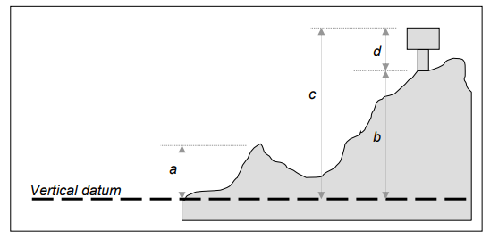

Figure 1 – heights and elevations (source IHO Publication S-57 UoC)

***4.2 S-57 Geo-Objects***

The storage of a DTM/DSM in S-57 is described in S-57 Appendix B.1: ENC Product Specification, Annex A: Use of the Object Catalogue for ENC, Edition 4.2.0 – April 2020.

### **4.2.1 Soundings**

### Geo Object: Sounding (SOUNDG)

### Attributes: EXPSOU (exposition of sounding)

### NOBJNM OBJNAM (object name)

### QUASOU (quality of sounding measurement)

### SOUACC (sounding accuracy) – see the use of the meta object M_QUAL

### STATUS

### TECSOU (technique of sounding measurement) – only for lower reliability soundings.

### VERDAT (vertical datum)

### INFORM

### NINFOM

### SORDAT (source date) – the production date of the source, e.g. the date of measurement

### **4.2.2 Depth contours**

### Geo object: Depth contour (DEPCNT)

### Attributes: VALDCO – value of depth contour

### VERDAT – INFORM NINFOM

### **4.2.3 Depth Areas**

### Geo Object: Depth Area (DEPARE)

### Attributes: DRVAL1 (depth range value 1) – shoalest

### DRVAL2 (depth range value 2) – deepest

### QUASOU (quality of sounding measurement)

### SOUACC

### VERDAT

### INFORM

### NINFOM

### **4.3 S-101 Geo-Objects**

### The storage of a DTM/DSM in S-101 is described in the S-101 Annex A – Data Classification and Encoding Guide (DCEG) Edition 1.0.1 March 2021.

### 4.3.1 Sounding

*S-101 Geo Feature: Sounding (SOUNDG)*

*Primitives: Pointset*

*S-101 Attribute: feature name – multiplicity 0,\**

*display name – multiplicity 0,\**

*language – multiplicity 0,\**

*name (OBJNAM, NOBJNM) – multiplicity 1,1*

*quality of vertical measurement (QUASOU) – multiplicity 0,\**

*reported date (SORDAT) – multiplicity 0,1*

*status (STATUS) - multiplicity 0,1 (only one value possible: existence doubtful)*

*technique of vertical measurement (TECSOU) – multiplicity 0,\**

*vertical uncertainty – multiplicity 0,1 (multiplicity is proposed to be 1,1 by S-101PT)*

*uncertainty fixed (SOUACC) – multiplicity 1,1*

*uncertainty variable – multiplicity 0,1*

*scale minimum (SCAMIN) – multiplicity 0,1*

### 4.3.2 Depth contour

*S-101 Geo Feature: Depth Contour (DEPCNT)*

*Primitives: Curve*

*S-101 Attribute: value of depth contour (VALDCO) – multiplicity 1,1*

*scale minimum (SCAMIN) – multiplicity 0,1*

### 4.3.3 Depth Areas

*S-101 Geo Feature: Depth Area (DEPARE)*

*Primitives: Surface*

*S-101 Attribute: depth range maximum value (DRVAL2) – multiplicity 1,1*

*depth range minimum value (DRVAL1) - multiplicity 1,1*

## 4.4 S-102

The storage of a DTM/DSM in S-102 is described in the S-102 Bathymetric Surface Product Specification (Edition 2.0.0 October 2019). The S-102 Feature Catalogue layout is shown in Table 2.

Table 3: layout of the S-102 Feature Catalogue

|  |  |
| --- | --- |
| classification | unclassified |
| Simple Attribute |  |
| name | Depth |
| definition | the vertical distance from a given water level to the bottom |
| code | depth |
| alias | DEPTH |
| value Type | real |
|  |  |
| Simple Attribute |  |
| name | uncertainty |
| definition | The interval (about a given value) that will contain the true value of the measurement at a specific confidence level |
| code | uncertainty |
| remarks | Represents a +/- value defining the possible range of associated depth expressed a positive number |
| value Type | real |
|  |  |
| Feature Type |  |
| name | Bathymetry Coverage |
| definition | A set of value items required to define a dataset representing an depth calculation and its associated uncertainty. |
| code | BathymetryCoverage |
| multiplicity | 1..1 (always 1) |
| attribute ref | depth |
| multiplicity | 1..1 (always 1) |
| attribute ref | uncertainty |
|  |  |
| feature Use Type | geographic |
| permitted Primitives | coverage |

# *5. Data Generalization*

Cartographic Generalization is the selection and simplified representation of detail appropriate to the scale and/or the purpose of a map (ICA 1967). Data quality and generalization for map production are closely related. The quality of the source data is one of the controls of generalization, along with map purpose, map scale, and graphic limits (see Robinson *et al.,* 1995), and, as such, influences map generalization process. Generalization relies on the quality of the source data. The more reliable and precise the data, the more detail exists in the data that needs to be generalized. Conversely less generalisation is required when the source data is poor and less complete. It must also be noted that the process of generalization also impacts the quality of the output data. Generalization needs to deliver data that is fit for purpose. The quality of the generalised data is an evaluation of how closely the data fulfils the specified requirements (Regnauld, 2015). The output of the generalization must not give the users the false impression of completeness and quality of the data better than the reality.

The compilation of bathymetry on nautical charts is one of the most complicated and time-consuming generalization processes. The charted bathymetry is derived from a more detailed (source) dataset, either the survey data or a larger scale chart, with cartographic generalization.

***5.1 Cartographic Constraints***

The generalization process is a continuous compromise between the legibility, topology, morphology, and safety constraints which, are often incompatible with each other. The following four constraints describe the general requirements of the final chart to ensure it is fit for purpose.

1. Safety: depth information on the chart must not appear deeper than the source data at any location. This is the most important constraint in nautical cartography that must be respected at all times.
2. Legibility: information should be shown in a clear and efficient way that does not cause confusion.
3. Topology: the topology of the depicted chart elements must be correct, spatial relationships and relative distances between objects must be maintained e.g,, soundings must not be displaced, no gaps between skin of the earth features must exist, depth curves must not cross.
4. Morphology: morphological details of the seafloor (slope, roughness) must be maintained as much as possible.

IHO S-4 and S-52 publications provide a number of guidelines /rules on symbol sizes and generalization of features that can be used for the evaluation of the quality of the final product.

***5.2 Compilation Guidelines***

IHO publication S-4, S-57, S101 provide HO’s with guidance related to a number of issues related to the compilation of nautical charts. Most notable in regard to a consideration of the quality of bathymetric data are guidance rated to:

1. Depth discontinuities between surveys
2. The geometry of depth areas that are not closed on the source.

A single survey will measure the seafloor in a certain area relative to Chart Datum. Resulting from this single survey, one or more depth areas will be created. Depth areas have two attributes (depth range minimum value, depth range maximum value). A collection of surveys will measure a wider area of the seafloor, resulting in probably more depth areas, depending on the slope of the seabed. In practice many depth areas share the same Quality of Bathymetric Data value. If a survey is carried out to a specific depth which is not bounded by a depth contour line, than the resulting Depth Area will have two separate Quality of Bathymetric Data values.

ENCs should form a seamless coverage in the navigable waters of the producer’s area of responsibility. However, it is often impractical to do so for all ECDIS display scales, and therefore S-101 ENCs declare a scale range, which dictate between what scales the data can be used.

When assigning meaningful Quality of Bathymetric Data information in an ENC, the Hydrographic Office should take into account the maximum display scale and minimum display scale. [4]

|  |  |
| --- | --- |
| maximum display scale | minimum display scale |
| 700,000 | > 700,000 |
| 350,000 | 700,000 |
| 180,000 | 350,000 |
| 90,000 | 180,000 |
| 45,000 | 90,000 |
| 22,000 | 45,000 |
| 12,000 | 22,000 |
| 8,000 | 12,000 |
| 4,000 | 8,000 |
| 3,000 | 4,000 |
| 2,000 | 3,000 |
| 1,000 | 2,000 |

The largest chart scale available will have the maximum level of detail (LoD) and distinctiveness of areas of Quality of Bathymetric Data. The Hydrographic Office should assign values of Quality of Bathymetric Data at the highest level of detail possible. Then lower scale charts will inherit these values. Adjacent areas of Quality of Bathymetric Data will merge together (aggregation process) in smaller scale charts. The lowest value of two (or more) merging areas should be the aggregated value in the smaller scale chart.

## 5.3 Validation Checks

In order to monitor and manage the quality of data throughout the process of chart compilation it is necessary to have an initial pre-process that checks that the source data is of suitable quality, and a post-process that checks that the result meets all necessary requirements. These are completed by targeted local checks performed within generalization steps. (Regnauld, 2015).

IHO Special Publication S-58 (IHO, 2018) contains a list of validation checks that aim to ensure that ENCs are compliant with S-57. Software that performs S-58 validation (e.g., SevenCs Analyzer, ESRI ArcGIS for Maritime, Teledyne CARIS S-57 Composer, C-MAP dKart Inspector) provide error reports for the ENC in question as well as errors with objects in the adjoining ENCs. The error are classified into three categories according to the risk they pose for the safety of navigation:

1. Warning : an error which may be duplication or an inconsistency which will not noticeably degrade the usability of an ENC in ECDIS
2. Error: may degrade the quality of the ENC through appearance or usability but which will not pose a significant danger when used to support navigation.
3. Critical Error: would make an ENC unusable in ECDIS through not loading; or causing an ECDIS to crash; or presenting data which is unsafe for navigation.

The list of validation checks in S-58 is not exhaustive; new validation checks are added and others are upgraded/ downgraded from one category to another as a result of the lessons learned from real-world situations and research in the field.

# 6. Data Quality Components

Information on the quality of geographic data allows a data producer to evaluate how well a dataset meets the criteria set forth in its product specification and assists data users in evaluating a product’s ability to satisfy the requirements for their particular application. ISO 19157 (2013) establishes the principles for describing evaluating and reporting data quality for geographic information. Working with data quality involves:

* understanding of the concepts of data quality related to geographic data.
* defining data quality conformance levels in data product specifications or based on user requirements. Establishment of data product specifications is described in ISO 19131:2007.
* specifying quality aspects in application schemas;
* evaluating data quality.
* reporting data quality.

A data quality evaluation can be applied to dataset series, a dataset, or a subset of data within a dataset, sharing common characteristics so that its quality can be evaluated. Data quality is described using data quality elements. Data quality elements and their descriptors are used to describe how well a dataset meets the criteria set forth in its data product specification or user requirements and provide quantitative quality information. When data quality information describes data that have been created without a detailed data product specification or with a data product specification that lacks quantitative measures and descriptors, the data element may be evaluated in a non-quantitative subjective way as a descriptive result for each element. Some quality related information is provided by purpose, usage and lineage. Quantitative data quality elements may have associated quality (termed *metaquality*). To facilitate comparisons, it is essential that the results of the quality reports are expressed in a comparable way and that there is a common understanding of the data quality measures that have been used. Figure 7 provides an overview of the model of data quality.

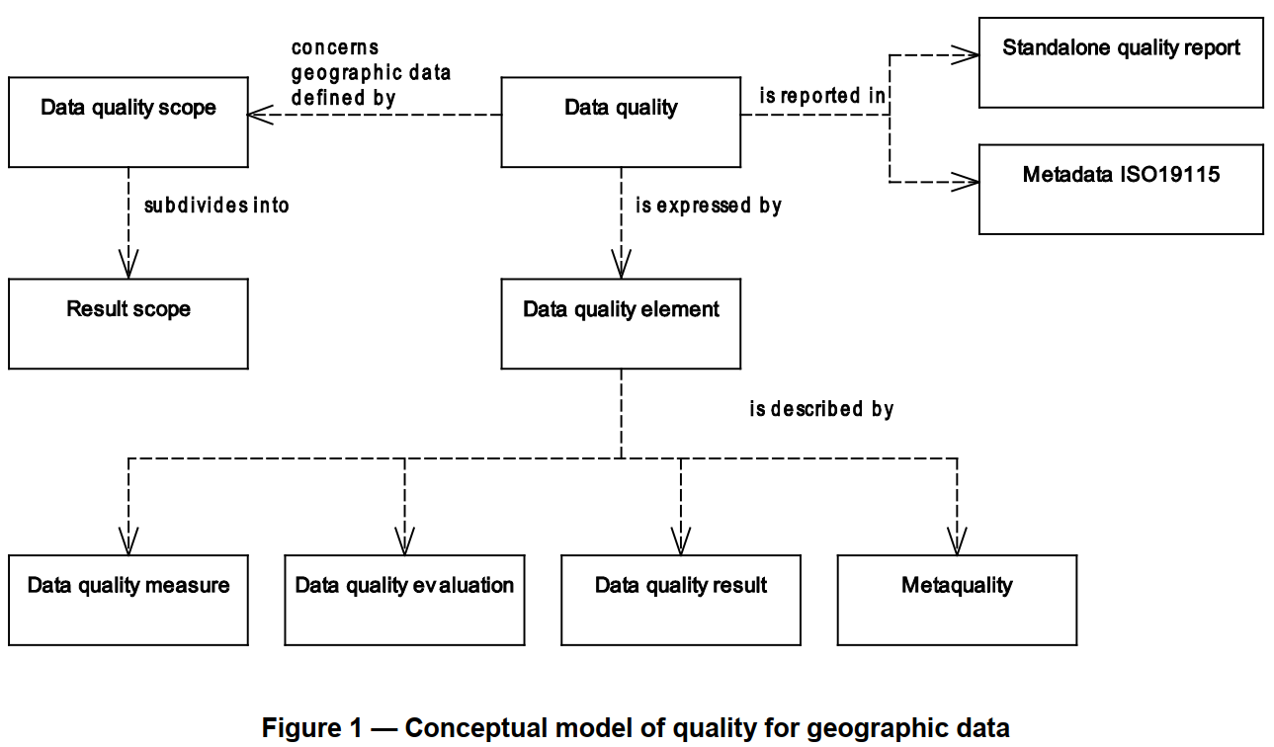

Figure 2: Conceptual Model of quality for geographic data

## 6.1 Data Quality Unit

When describing the quality of geographic data, different quality elements and different subsets of the data may be considered. In order to describe these, *data quality units* are used. A data quality unit is the combination of a *scope* and data quality *elements*. The *scope* of the data quality unit(s) specifies the extent, spatial and/or temporal, and/or common characteristic(s) that identify the data on which data quality is to be evaluated. One data quality scope shall be specified for each data quality unit. One data quality report (metadata or standalone quality report – see Section 6.3) may encompass several data quality units, since scopes are often different for individual data quality elements. These different scopes may be, for example, spatially separate, overlapping or even sharing the same extents.

## 6.2 Data Quality Elements

Data quality shall be described using the *data quality elements*. Data quality elements evaluate the difference between the dataset and the *universe of discourse* (i.e., the perfect dataset that corresponds to the data product specification). A data quality element is a component describing a certain aspect of the quality of geographic data. Six different categories are defined, i.e., Completeness, Logical Accuracy, Positional Consistency, Thematic Accuracy, Temporal Quality, and Usability (Figure 3). In detail:

**Completeness** is the presence or absence of features and along with positional accuracy and thematic accuracy (explained bellow), are those that are used to describe how the dataset relates to the universe of discourse. It consists of:

* *commission* (excess data present in a dataset), and
* *omission* (data absent from a dataset).

**Logical consistency** is the degree of adherence to logical rules of data structure, attribution, and relationships (data structure can be conceptual, logical, or physical). Is the only one among the quality elements that can be fully evaluated without ground truth knowledge It consists of:

* *conceptual* *consistency* – adherence to rules of the conceptual schema.
* *domain* *consistency* – adherence of values to the value domains.
* *format* *consistency* – degree to which data is stored in accordance with the physical structure of the dataset.
* *topological consistency* – correctness of the explicitly encoded topological characteristics of a dataset.

The **positional accuracy** is the accuracy of the position of features within a spatial reference system. It consists of:

* *absolute* or *external accuracy* – closeness of reported coordinate values to values accepted as or being true.
* *relative* or *internal accuracy* – closeness of the relative positions of features in a dataset to their respective relative positions accepted as or being true.
* *gridded data positional accuracy* – closeness of gridded data spatial position values to values accepted as or being true. The accuracy of gridded data may be described using the same data quality measures as for the horizontal positional uncertainty. The band values in rasters may be described using the quantitative attribute accuracy of thematic accuracy.

**Thematic accuracy** is defined as the accuracy of quantitative attributes and the correctness of non-quantitative attributes and of the classifications of features and their relationships. It consists of:

* *classification correctness* – comparison of the classes assigned to features or their attributes to a universe of discourse (e.g., ground truth or reference data);
* *non-quantitative attribute correctness* – measure of whether a non-quantitative attribute is correct or incorrect.
* *quantitative attribute accuracy* – closeness of the value of a quantitative attribute to a value accepted as or known to be true.

**Temporal quality** is defined as the quality of the temporal attributes and temporal relationships of features. Temporal quality consists of a mix of data quality elements that partly is dependent upon logical rules (comparable to logical consistency) and partly needs ground truth knowledge to be evaluated (in similar way as *completeness* and the *accuracy* elements):

* *accuracy of a time measurement* – closeness of reported time measurements to values accepted as or known to be true.
* *temporal consistency* – correctness of the order of events in the dataset.
* *temporal validity* – validity of data with respect to time. The temporal validity may be treated with the same data quality measures as for other domain specific attribute values.

**Usability element** is used for a quality evaluation based on user requirements which cannot be covered by the other five data quality categories. It may also be used to provide an aggregation result where results from several data quality categories are *aggregated* (for example, overall conformity to one specification). That is because an evaluation based on a single data quality element is often not sufficient. The quality of a dataset may be represented by one or more *aggregated data quality result* (ADQR). The ADQR combines quality results from data quality evaluations based on different data quality elements or different data quality scopes. A dataset may be deemed to be of an acceptable aggregate quality even though one or more individual data quality results fails acceptance. Aggregation should therefore only be used when compelling reasons exist. The meaning of the aggregate data quality result should always be made clear.  
As the ADQR may be difficult to fully understand, the meaning of the aggregate data quality result should be understood before drawing conclusions based on aggregate data quality results for the quality of the dataset. Examples of methods that may be used for producing an ADQR are given in Section J.2 to J.4 of ISO (2013), e.g., 100% Pass/Fail, Weighted Pass/Fail, and Max/Min Value.

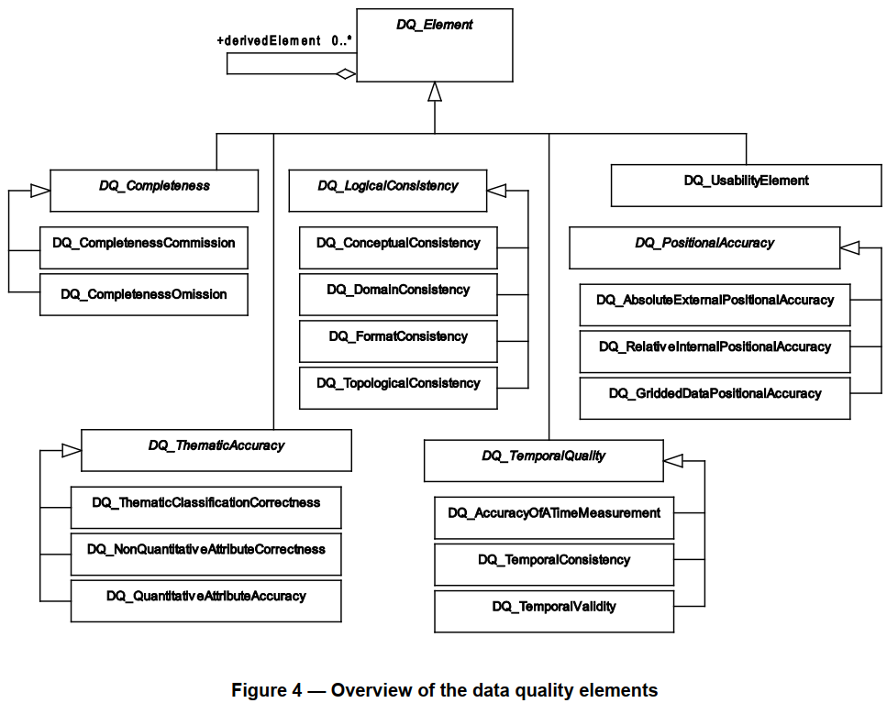

Figure 3: Overview of the data quality elements

Table 4 shows the data quality elements relevant to bathymetric data.

Table 4: Data quality elements for bathymetric data.

|  |  |  |  |  |  |
| --- | --- | --- | --- | --- | --- |
| DQ element | DQ sub-element | Definition | Evaluation scope | Application to spatial representation types | |
| Vector | Grid |
| Completeness | Commission | excess data present in the dataset. | dataset / dataset series | X |  |
| Omission | data absent from the dataset. | dataset / dataset series / spatial object type | X | X |
| Logical consistency | Conceptual consistency | adherence to rules of the conceptual schema | spatial object / spatial object type | X | X |
| Domain consistency | adherence of values to the value domains | spatial object / spatial object type | X |  |
| Format consistency | degree to which data is stored in accordance with the physical structure of the dataset, as described by the scope | dataset / dataset series | X | X |
| Topological consistency | correctness of the explicitly encoded topological characteristics of the dataset, as described by the scope | spatial object type / dataset series / dataset | X |  |
| Positional accuracy | Absolute (external) accuracy | closeness of reported coordinate values to values accepted as or being true | spatial object / spatial object type / dataset series / dataset | horizontal component |  |
| vertical component | vertical component |
| Positional accuracy | Gridded data position accuracy | closeness of gridded data position values to values accepted as or being true | spatial object / spatial object type / dataset series / dataset |  | horizontal component |
| Thematic Accuracy |  |  |  |  |  |
| Temporal Quality |  |  |  |  |  |
| Usability |  |  |  |  |  |

## 6.3 Quality Descriptors

Data quality elements and their descriptors are used to evaluate how well a dataset meets the criteria set forth in its data product specification or user requirements and provide quantitative quality information. An evaluation of a data quality element is described by the type of evaluation (*measure),* the procedure used to evaluate the measure (*method), and* the output of the evaluation (*result)*. In detail:

### 6.3.1 Measure

Measure is the type of evaluation. A data quality element should refer to one measure only. An example of measure can be the percentage of the values of an attribute which are correct. A single data quality measure might be insufficient for fully evaluating the quality of the data specified by a data quality scope and providing a measure of quality for all possible utilizations of a dataset. A combination of data quality measures can give useful information. Multiple data quality measures may be reported for the data specified by a data quality scope.

To facilitate dataset comparisons, it is necessary that the results in the data quality reports are expressed in a comparable way and that there is a common understanding of the data quality measures that have been used. In order to make evaluations and data quality reports (metadata or a standalone quality report) from different sources comparable, standardized data quality measures shall be used when possible.

### 6.3.2 Method

The evaluation method is the procedure used to evaluate the measure. Data quality evaluation method should be included for each applied data quality measure. Different evaluations are often used for the various data quality elements.

Based on the guidelines of ISO 19157 and its predecessors, the ISO 19113 and ISO 19114, a number of studies have tried to develop methods for assessing data quality and its adherence to the decided measures (see Section 7).

### 6.3.3 Result

The result is the output of the evaluation method used to evaluate the specific type of evaluation of the quality element. Quality frequently differs between various parts of the dataset for which quality is evaluated. Therefore, several evaluations may be applied for the same data quality element to more completely and in more detail describe quantitative data quality. To avoid repeating the measure and evaluation procedure descriptions in several instances of data quality element, several results with individual result scopes can be used. For example, a dataset may contain features of identical type whose positions have been established with separate methods yielding different positional accuracies. The same quality evaluation method and the same measure are however applied for the whole dataset, and provide different results depending on the data acquisition method. In this case, it may be desirable to have several results with individual result scopes (the area covered by each data acquisition method) and one data quality scope (the dataset). A result can be *quantitative*, *conformance*, *descriptive*, or *coverage* result:

* **Quantitative** result **–** the outcome in numerical form such as statistics, percentages, etc.
* **Conformance** result **–** the outcome of comparing the value or set of values obtained from applying a measure to the data specified by a data quality scope with a specified acceptable conformance quality level.
* **Descriptive** result **–** thesubjective evaluation of an element, expressed with a textual statement, when a quantitative result is not possible (e.g., with thematic and geoscientific observations).
* **Coverage** result **–**the result of a data quality evaluation, organized as a coverage. This is documented in ISO 19115-2:2009.

Below are some measure and result examples for the quality elements discussed in Section 6.2.

**Completeness :**

**Commission**: Number OR rate of excess items, i.e., items that should not have been in the dataset and are present.

**Omission**: Number OR rate of missing items, i.e., items that should have been in the dataset and are missing.

**Logical Consistency:**

**Conceptual**: number of items not compliant with the rules of the relevant conceptual schema. If the conceptual schema explicitly or implicitly describes rules, these rules shall be followed, e.g., invalid placement of features within a defined tolerance, duplication of features and invalid overlap of features.

**Domain**: value domain conformance. Example: True as result for an item that is conforming to its value domain.

**Format**: physical structure conflicts number. Example: 5 as a result for features type encoded with more than 3 characters when the requirement in the specification is 3.

**Topological**: missing connections (e.g., Figure 9 for undershoot, Figure 10 for overshoot), self-intersect (Figure 11), self-overlap (Figure 12).

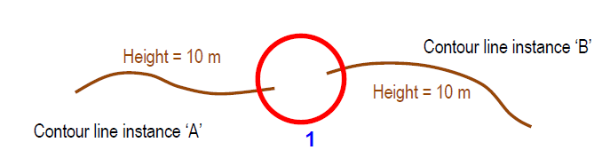

Figure 4: Example of missing connections due to undershoots.

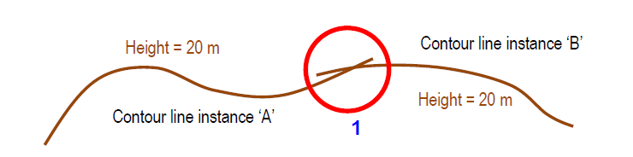

Figure 5: Example of rate of missing connections due to overshoots.

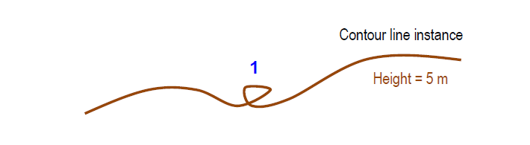

Figure 6: Example of rate of invalid self-intersect errors.

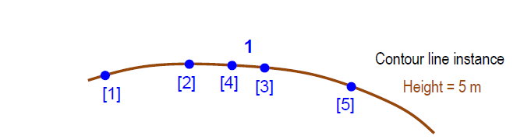

Figure 7: Example of rate of invalid self-overlap errors (• vertices [digitized order]).

**Positional Consistency:**

**Absolute** or **external**: horizontal accuracy at 95 % significance level, e.g., 5 m;

**Relative** or **internal** accuracy – vertical error. That is the evaluation of the random errors of one relief feature to another in the same dataset or on the same map/chart. It is a function of the random errors in the two elevations with respect to a common vertical datum, e.g., 1.1 m;

**Gridded** **data** positional accuracy – the band values in rasters must be within 95%.

**Thematic Accuracy:**

**Classification correctness** – number of incorrectly classified features, e.g., 12 incorrectly classified features.

**Non-quantitative** **attribute** correctness – rate of incorrect attribute values, e.g., 12%.

**Quantitative attribute** accuracy – attribute value uncertainty at 90 % significance level.

**Temporal Quality:**

**Accuracy of a time measurement** – time accuracy at 68 % significance level, the start date (DATSTA) field cannot contain a value in the future.

**Temporal consistency** – chronological error, i.e., the indication that an event is incorrectly ordered against the other events (e.g., True – 2 events in the dataset are not ordered correctly), the end date (DATEND) shall be the same as or after start date (DATSTA).

**Temporal validity** –date value shall be in a specific format, e.g., “CCYYMMDD” (20210423).

## 6.4 Metaquality

Metaquality provides quality information about quality evaluation. Metaquality elements are a set of quantitative and qualitative statements about a quality evaluation and its result. The knowledge about the quality and the suitability of the evaluation method, the measure applied, and the given result may be of the same importance as the result itself. Metaquality may be described using *confidence*, *representativity*, and *homogeneity*:

* **Confidence** – trustworthiness of a data quality result.
* **Representativity** – degree to which the sample used has produced a result which is representative of the data within the data quality scope.
* **Homogeneity** – expected or tested uniformity of the results obtained for a data quality evaluation.

A metaquality element is described by the same descriptors as for the quality element (measure, evaluation method and result, with the addition of *related quality element* (i.e., the element on which the metaquality element applies)*.*

The main difficulty is to aggregate these measures in a way that can help decide if a set of data is fit for a particular use. While the criteria related to clean geometries and topology can fairly easily be checked and sometimes automatically fixed, the others are more difficult to check, and require a reference dataset.

**7. Data Quality Evaluation**

Datasets are continually being created, updated and merged with the result that the quality or a component of the quality of a dataset may change. The quality of a dataset can be affected by three conditions:

* when the data is modified in some way.
* when a dataset’s data product specification is modified or new user specified data quality requirements are identified,
* when the real world has changed.

The quality evaluation process is a sequence of steps followed to produce a quality evaluation result. When the geographic data evaluated is heterogeneous with different quality for different parts, tests should be applied to suitable parts of the data.

## 7.1 Process

Figure 8 illustrates a possible workflow for evaluating data quality and Table 5 the process steps (see ISO 19157 Section E.3 for a study case).

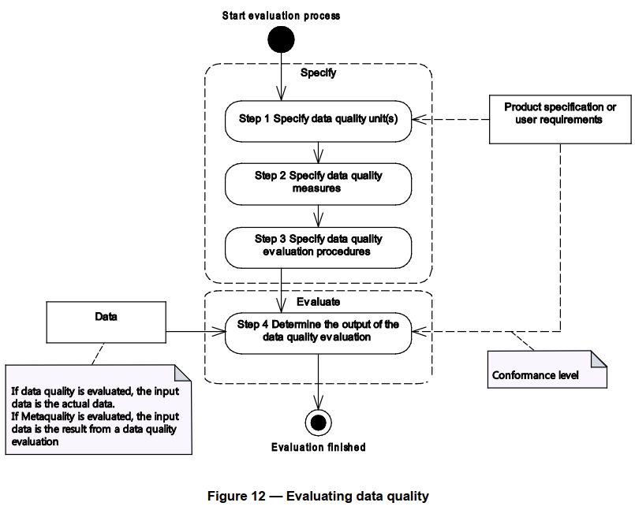

Figure 8. Data quality evaluation workflow (ISO, 2013)

Table 5. Evaluation process steps (ISO, 2013)

|  |  |  |
| --- | --- | --- |
| Step | Action | Description |
| 1 | Specify data quality unit(s) | A data quality unit is composed of a scope and quality element. All data quality elements relevant to the data for which quality is to be described should be used. |
| 2 | Specify data quality measures | If applicable a measure should be specified for each data quality element. |
| 3 | Specify data quality evaluation procedures | A data quality evaluation procedure consists of applying one or more evaluation methods |
| 4 | Determine the output of the data quality evaluation | A result is the output of applying the evaluation |

A data quality evaluation procedure comprises one or more data quality evaluation methods. Data quality evaluation methods can be divided into two main classes, *direct* and *indirect*:

* **Direct** evaluation method is a method of evaluating the quality of a dataset based on inspection of the items within the dataset.
* **Indirect** evaluation methods infer or estimate data quality using information on the data such as lineage. An indirect evaluation method is a method of evaluating the quality of a dataset based on external knowledge or experience of the data product and can be subjective.

Direct evaluation methods should be used in preference to indirect evaluations and are further sub classified into *internal* and *external based on the* source of the information needed to perform the evaluation.

* **Internal** **direct** data quality evaluation uses only data that resides in the dataset being evaluated.
* **External direct** quality evaluation requires reference data external to the dataset being tested.

For both external and internal evaluation methods, either *full inspection* or *sampling* may be used:

* **Full inspection** tests every item in the population specified by the data quality scope. It is most appropriate for small populations or for tests that can be accomplished by automated means.
* **Sampling** means that tests are performed on subsets of the geographic data defined by the data quality scope. For detailed information on sampling strategies, the reader is referred to ISO 19157 Section F.4.

Quality evaluation procedures may be used in different phases of a product’s life cycle, for instance:

* **Development of a data product specification or user requirements** – Quality evaluation procedures may be used to facilitate the establishment of conformance quality levels that should be met by the final product.
* **Quality control during dataset creation** – At the production stage, the producer may apply quality evaluation procedures, either explicitly established or not contained in the data product specification, as part of the process of quality control.
* **Inspection for conformance to a data product specification** – On completion of the production, a quality evaluation process may be used to produce and report data quality results to determine whether a dataset conforms to its data product specification or not. If the dataset passes inspection the dataset is considered to be ready for use. The outcome of the inspection will be either acceptance or rejection of the dataset.
* **Evaluation of dataset conformance to user requirements** – Quality evaluation procedures may be used to establish if a dataset meets the conformance quality levels specified in user requirements.
* **Quality control during dataset update** – Quality evaluation procedures are applied to dataset update operations, both to the items being used for update and to benchmark the quality of the dataset after an update has occurred.

## 7.2 Order

When evaluating geographic data, one individual error may influence several data quality elements. The usual order that is followed is:

1. Format consistency: The very first to be evaluated is the readability (or interpretability) of the data to decide whether it is possible to decode/read/understand the data or not. Not interpretable data should be reported and ignored in the further evaluation. The result of the format consistency should describe which parts of the data are not readable.
2. Logical consistency: Decide if the rules set up for the dataset are followed. Parts of the dataset not conforming to the rules should be ignored in the further evaluation.
3. Completeness: The next step in the evaluation is the feature existence aspect covered by  
   completeness. To evaluate this, the features in the actual dataset and the ground truth data are compared, and commissions and omissions reported.
4. Accuracy (positional, thematic, and temporal aspects): The last step in the evaluation covers the accuracy aspect, measuring the deviation between actual and ground truth feature properties. These measurements can be based only on parts of the dataset present in both the actual dataset and the universe of discourse.

## 7.3 Reporting

Data quality reporting can aid discovery and encourage use of the dataset, demonstrate the compliance to a data product specification or to user requirements and permit optimal decision making. Data quality shall be primarily reported as *metadata* however a a *standalone quality report* may additionally be created.

* **Metadata**: The metadata aims at providing short, synthetic, and generally structured information to enable metadata interoperability and web services usage (e.g., M_QUAL).
* **Standalone quality report:** The standalone quality report may be used to provide fully detailed information about the data quality evaluation. It should contain sufficient information to meaningfully describe the relevant aspects of data quality and their results.

**8. Evaluating Data Quality**

## 8.1 General

Data quality is evaluated in relation to the six data quality elements previously described in section 6.2:

* **Completeness**
* **Logical consistency**
* **Positional Accuracy**
* **Thematic Accuracy**
* **Temporal Quality/Accuracy**
* **Usability**

## 8.2 CATZOC

IHO S-57 provides the existing guidance of how HOs should populate information about quality, reliability and accuracy of bathymetric data. The meta object M_QUAL for an assessment of the quality of bathymetric data is mandatory for areas containing depth data or bathymetry. More detailed information about CATZOC can be found in IHO Publication S-67.

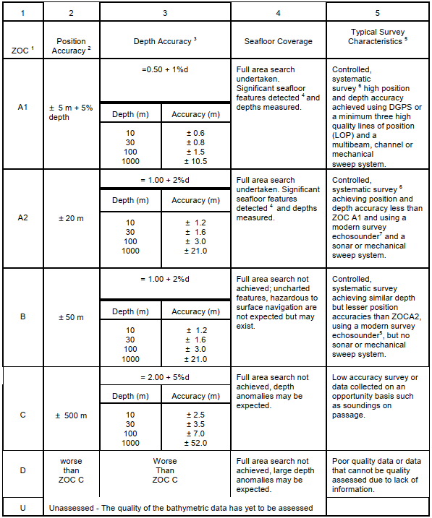

Figure 8. Zones of Confidence table (Source: IHO S-57 Ed3.1 Supp 3 (Jun 2014), pp 13-14)

## 8.3 S-44 – CATZOC comparison

S-44 Table 1 lists the minimum standards for Hydrographic Surveys. It is a mixture of Bathymetric Data and non-Bathymetric Data in the water/at the surface and of non-Bathymetric Data connected to land (coastline/topography significant to navigation). S-57 and S-101 meta object M_QUAL (meta_quality) defines areas within which a uniform assessment exists for the quality of bathymetric data. The differences between S-57 and S-101 is that in S-101 the attribute *Category of temporal variation* has been included and that Data assessment can be assigned a value of assessed (Oceanic). This *Category of temporal variation* attribute will by default be set to value 5: *unlikely to change* and the Hydrographic Office is recommended to set this value for each area to the appropriate level when upgrading to S-101.

S-44 and S-57 share the following concepts:

1. Horizontal accuracy (position)
2. Vertical accuracy (depth)
3. Completeness (full seafloor coverage)
4. Isolated dangers (feature detection)

The S-57 M_QUAL has a mandatory attribute CATZOC (=Category Zone of Confidence). There is a one-to-one or many-to-one relation between S-44 assigned values of surveys and S-57 assigned values of CATZOC. This means that a single survey can translate directly into a single value of CATZOC or that an adjacent set of surveys translate into a single value of CATZOC. In theory a single survey can be separated into more than one CATZOC value but this is very unlikely to happen. To relate both concepts, a cross-table is presented for each of the four sharing concepts:

Check tables

Table 6: cross reference on horizontal accuracy

|  |  |  |  |  |  |
| --- | --- | --- | --- | --- | --- |
|  | ZOC value | Special Order | 1a | 1b | 2 |
| A1 | ± 5m + 0.05* depth | 2 m | ± 5m + 0.05* depth | ± 5m + 0.05* depth | 20 m + 0.1* depth |
| A2 | ± 20m | 2 m | ± 5m + 0.05* depth | ± 5m + 0.05* depth | 20 m + 0.1* depth |
| B | ± 50m | 2 m | ± 5m + 0.05* depth | ± 5m + 0.05* depth | 20 m + 0.1* depth |
| C | ± 500m | 2 m | ± 5m + 0.05* depth | ± 5m + 0.05* depth | 20 m + 0.1* depth |
| D | > 500m | 2 m | ± 5m + 0.05* depth | ± 5m + 0.05* depth | 20 m + 0.1* depth |

Table 7: cross reference on vertical accuracy

|  |  |  |  |  |  |
| --- | --- | --- | --- | --- | --- |
|  | ZOC value | Special Order | 1a | 1b | 2 |
| A1 | ± 0.5m + 0.01* depth | √((0.252 + (0.0075*depth)2) | √((0.52 + (0.013*depth)2) | √((0.52 + (0.013*depth)2) | √((1.02 + (0.023*depth)2) |
| A2 | ± 1.0m + 0.02* depth | √((0.252 + (0.0075*depth)2) | √((0.52 + (0.013*depth)2) | √((0.52 + (0.013*depth)2) | √((1.02 + (0.023*depth)2) |
| B | ± 1.0m + 0.02* depth | √((0.252 + (0.0075*depth)2) | √((0.52 + (0.013*depth)2) | √((0.52 + (0.013*depth)2) | √((1.02 + (0.023*depth)2) |
| C | ± 2.0m + 0.05* depth | √((0.252 + (0.0075*depth)2) | √((0.52 + (0.013*depth)2) | √((0.52 + (0.013*depth)2) | √((1.02 + (0.023*depth)2) |
| D | > 2.0m + 0.05* depth | √((0.252 + (0.0075*depth)2) | √((0.52 + (0.013*depth)2) | √((0.52 + (0.013*depth)2) | √((1.02 + (0.023*depth)2) |

Table 8: cross reference on completeness

|  |  |  |  |  |  |
| --- | --- | --- | --- | --- | --- |
|  | ZOC value | Special Order | 1a | 1b | 2 |
| A1 | YES | YES | YES | NO | NO |
| A2 | YES | YES | YES | NO | NO |
| B | NO | YES | YES | NO | NO |
| C | NO | YES | YES | NO | NO |
| D | NO | YES | YES | NO | NO |

Table 9: cross reference on isolated dangers

|  |  |  |  |  |  |
| --- | --- | --- | --- | --- | --- |
|  | ZOC value | Special Order | 1a | 1b | 2 |
| A1 | detected (2 meter, 10% of depth (>40m)) | cubic features > 1 meter | cubic features > 2 meter, 10% of depth (>40m) | NA | NA |
| A2 | detected (2 meter, 10% of depth (>40m)) | cubic features > 1 meter | cubic features > 2 meter, 10% of depth (>40m) | NA | NA |
| B | not expected but may exist | cubic features > 1 meter | cubic features > 2 meter, 10% of depth (>40m) | NA | NA |
| C | unknown, depth anomalies may be expected | cubic features > 1 meter | cubic features > 2 meter, 10% of depth (>40m) | NA | NA |
| D | unknown, large depth anomalies may be expected | cubic features > 1 meter | cubic features > 2 meter, 10% of depth (>40m) | NA | NA |

When assigning a CATZOC value, HO’s are recommended to follow the guideline (paper DQWG14-06B) developed by the DQWG. This consists of stages in the following order:

1. Data assessment
2. Category of temporal variation (S-101 only)
3. Significant features detected
4. Least depth of significant features known
5. Full seafloor coverage achieved
6. Depth accuracy
7. Positional accuracy

The result is then computed by going through these 7 stages and indicating a valid (green) or fault (red) outcome:

Check 1: Data assessment

|  |  |  |  |  |  |  |
| --- | --- | --- | --- | --- | --- | --- |
| ZOC | Special Order | Order 1a | Order 1b | Order 2 | unknown | Oceanic |
| A1 | valid | valid | valid | valid | fault | fault |
| A2 | valid | valid | valid | valid | fault | fault |
| B | valid | valid | valid | valid | fault | fault |
| C | valid | valid | valid | valid | fault | fault |
| D | valid | valid | valid | valid | fault | fault |
| U | fault | fault | fault | fault | valid | fault |
| Oceanic | fault | fault | fault | fault | fault | valid |

If a CATZOC value is given U=unassessed or Oceanic, then no further checks are required.

Check 2: Category of temporal variation

This is regardless of the S-44 classification of the survey and will be further explained in a different paper. In S-57 and when upgrading to S-101, the default value of this attribute is “unlikely to change” and thus not affecting the outcome of this checking process. HO’s are however requested to assign the correct value to this attribute when making the upgrade to S-101.

Check 3: Significant features detected

|  |  |  |  |  |
| --- | --- | --- | --- | --- |
| ZOC | Special Order | Order 1a | Order 1b | Order 2 |
| A1 | valid | valid | fault | fault |
| A2 | valid | valid | fault | fault |
| B | valid | valid | valid | valid |
| C | valid | valid | valid | valid |
| D | valid | valid | valid | valid |

Check 4: Least depth of significant features known:

|  |  |  |  |  |
| --- | --- | --- | --- | --- |
| ZOC | Special Order | Order 1a | Order 1b | Order 2 |
| A1 | valid | valid | fault | fault |
| A2 | valid | valid | fault | fault |
| B | valid | valid | valid | valid |
| C | valid | valid | valid | valid |
| D | valid | valid | valid | valid |

Check 5: Full seafloor coverage achieved

|  |  |  |  |  |
| --- | --- | --- | --- | --- |
| ZOC | Special Order | Order 1a | Order 1b | Order 2 |
| A1 | valid | valid | fault | fault |
| A2 | valid | valid | fault | fault |
| B | valid | valid | valid | valid |
| C | valid | valid | valid | valid |
| D | valid | valid | valid | valid |

Check 6: Depth accuracy

----for 145m this if fails:

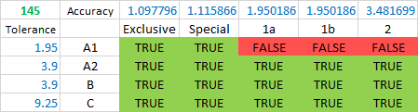

Check 7: Positional accuracy

|  |  |  |  |  |
| --- | --- | --- | --- | --- |
| ZOC | Special Order | Order 1a | Order 1b | Order 2 |
| A1 | valid | valid | valid | fault |
| A2 | valid | valid | valid | fault |
| B | valid | valid | valid | valid |
| C | valid | valid | valid | valid |
| D | valid | valid | valid | valid |

When combining these 7 steps we get the following result:

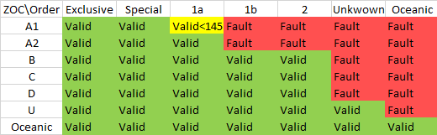

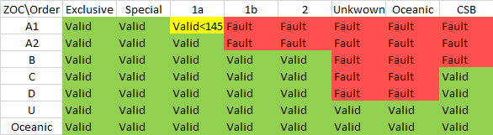

NOTE: valid does not mean appropriate. For example, a special order survey has the appropriate CATZOC level of A1. Values of A2, B, C and D are valid but does not justify the high quality of the original survey.

**8.4 Conversion matrices**

Work is ongoing to develop matrices to automatically convert s-44 values to CATZOC/QoBD values. The different parameters can be combined and used to calculate a final value.

## 9 HO Best Practice Examples/National Methodologies

Below is a summary of the methodologies for assigning CATZOC of the National Hydrographic Offices of Australia, Brazil, Finland, France, Italy, Japan, Netherlands, Norway, United Kingdom, and USA.

TABULATE findings?

Methods:

* Data Source
  + **AU**: ZOC (A2 max for LIDAR, B for scientific research and environmental MBES surveys, C max for opportunity soundings, D for soundings with little or no metadata and/or on unknown datums)
  + **BR:** according to ZOC table
  + **FI:** ZOC with modifications. In detail:
    - A: Full sea floor ensonification or sweep. A1 and A are combined to A.
    - B: Full seafloor coverage not achieved; depth anomalies may exist.
    - C: Full seafloor coverage not achieved; depth anomalies may be expected.
    - D: Not in use
    - U: Data unassessed.
  + **FR**: ZOC (for data from other HO can’t be better than B, D for reconnaissance survey, D for aerial photography, and from foreign charts CATZOC is used as is if exists or C for charts scale>250K and D for charts of scale <250K)
  + **IT**: ZOC but if from paper assigned B or C
  + **JP**: ZOC
  + **NL**: ZOC. approaches to main ports are A1 but cartographer can downgrade to A2 if less frequently surveyed and, e.g., area is changeable.
  + **NO**: ZOC
  + **UK**: ZOC in principle, B for LIDAR, C for SDB, D for aerial photography.
  + **US:** ZOC but if from USACE normally B (with exception A1 or A2), C for SDB, D when no survey record.
* Currentness
  + **BR**: only until 2014
  + **FR**: CATZOC is not downgraded due to the passage of time (mariners have to read CATZOC with M_SREL. For older surveys:
  + B if survey is after 2003 but source is not SHOM
  + since 1992: A2 if MBES, full seafloor, and sidescan; B if MBES + full sea floor
  + since 1980: A2 if scale>20K and sidescan
  + since 1970: B if scale >5K (P<20m) or scale>100K (P<100m), else C
  + pre-1935, C for coastal surveys, D for others
  + 1935-1970: C
  + post-1970:
  + **IT**: No
  + JP:
  + 1968-2011: B, C, D (depending on line spacing)
  + pre-1968: D
  + **NL**: downgrading is considered when a resurvey is overtime (i.a.w. survey plan)
  + **NO**:
  + A2 for 1990 -early 2000s when d>30m and B when d<30m
  + B for surveys 1950-1990
  + C for pre-1950
  + UK: No
  + US:
  + B for surveys after 1940 with SBES, nearshore, and survey scale > 40K
  + C for 1940-1990 offshore; 1940-1990, scale <40K and chart scale >survey scale; 1920 to 1940 on known horizontal and vertical datums.
  + D for pre-1940 with unknown horizontal or vertical datums; all pre-1920
  + Chart Scale
  + **IT:** No but D for Bands 1 and 2 (with the exception of UNSARE that is U)
  + Generalization
  + **BR**: No
  + **FR**: Yes (could be downgraded due to generalization for safety purposes)
  + **IT**: No
  + Seabed change/mobility:
  + **IT:** downgrades for instability of bathymetry
  + **NL**: D after extreme events
  + **UK**: D may be attributed after natural disaster
  + **US**: for any variation concerning vertical and horizontal accuracy

Other:

UNSARE:

* + **IT:** U but may change policy (e.g., D when overlaps bathy features)
  + **JP:** U
  + **UK**: D

DEPARE:

* + **IT**: Unsurveyed DEPARE 0-2 or 0-5m assigned D (when survey A1 or A2) or B,C. DEPARE at least 1cm side at scale

DRGARE:

* + **IT**: Regularly maintained A1, otherwise D

Notes:

* **AU**: CATZOC C category is too wide. It covers old (but good for their day) hydrographic surveys which cannot be transformed accurately to modern datums, and also opportunity soundings such as passage sounding.
* **NO**: Svalbard: For general information about the quality of the charts around Svalbard, reference is made to The Norwegian Pilot guide, Volume 7 and the information given in each chart. The glacier fronts seawards are continually changing. In general, the glacier fronts are receding. Observations exist where the glaciers have receded several hundred meters during the last decades. For this reason, contour lines and terrain close to the glacier can deviate from contour lines on the chart. Surveys are in some areas of Svalbard incomplete. Large areas have not been surveyed using modern technology but include some very old bathymetry. In the ENCs these areas have mostly been given CATZOC D.
* **UK**: Historically, many UK ENCs had their CATZOC populated using survey source, dates, scale and sounding technique (taken from the corresponding chart SOURCES diagram).

|  |  |  |  |  |  |  |  |  |  |
| --- | --- | --- | --- | --- | --- | --- | --- | --- | --- |
| Member State | Used Values | Sources | Usage Band dependent | Downgrading with | | Time dependent | | |  |
| time | gener/tion | 1 | 5 |  |  |
| Australia |  |  |  |  |  |  |  |  |  |
| Brazil | All |  |  |  |  | A1 | A2 |  |  |
| Finland |  |  |  |  |  |  |  |  |  |
| France |  |  |  |  |  |  |  |  |  |
| Italy |  |  |  |  | Yes |  |  |  |  |
| Japan |  |  |  |  |  |  |  |  |  |
| Netherlands |  |  |  |  |  |  |  |  |  |
| Norway |  |  |  |  |  |  |  |  |  |
| UK |  |  |  |  |  |  |  |  |  |
| USA |  |  |  |  |  |  |  |  |  |

Table 10

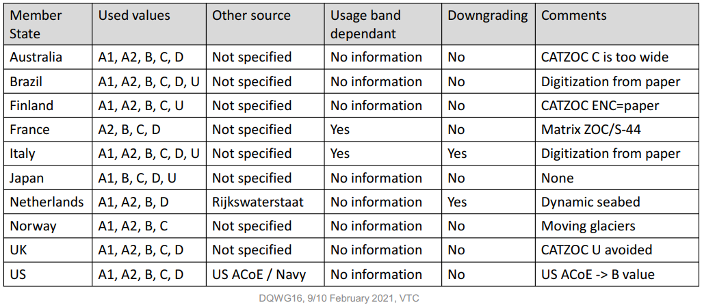

**US NOAA OCS Hydrographic Health Model**

# 10. Crowd Sourced Bathymetry

Definaition of CSB

# 11. Conclusions and recommendations

* Depth data can be represented by a vector model (S-57/S-101) and/or a grid model (S-102). The Producing Authority of an ENC, who also provides depth data in S-102 format, should ensure consistency between the two datasets (maintain integrity and positional consistency).
* In order to ensure consistency, as a minimum, the same vertical datum and realization of that vertical datum should be used when datasets are provided by the same Producing Authority.
* Coherence of depth data at different levels of detail should be maintained.
* There is a possible relationship between the ground sampling distance of the data captured, the intended scale of mapping and normal contour line vertical interval. This is further to be investigated to ensure that in a chart not too many contour lines are depicted giving a false sense of accuracy.
* Depth data has an associated uncertainty (mainly in a vertical sense). When combining different datasets, these uncertainties provide a degree of confidence to which data is the most representative to depict the shape of the seabed and additional man-made structures (wrecks).
* Using the associated uncertainties presented as meta-quality data, CSB may have additional value to existing nautical charts, most likely in areas where no gridded data exists and where soundings and depth contours have a high degree of uncertainty (remote areas).

1. INSPIRE D2.8.II.1 Data Specification on Elevation – Technical Guidelines
2. Satellite Derived Bathymetry
3. IHO Publication S-4 Regulations for International (INT) Charts and Chart Specifications of the IHO (Nov 2018), item B-611.1
4. S-101 DCEG par. 3.4 page 41